


Danial Reed
E.C. Barton & Company
870-336-6424
Danial.reed@ecbarton.com

New Home Outlet Store Hosting Hiring Event on May 13

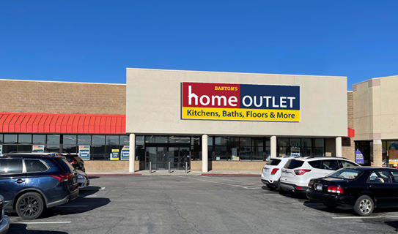
Jonesboro, AR (May 11, 2021) – E.C. Barton & Company announced earlier this month the opening of its new Home Outlet store in Joplin, Missouri. The new location at 440 S. Range Line Road in Joplin, will open in mid to late May and is now hiring for several open positions. A one day hiring event will take place on Thursday, May 13 from 10 am to 2 pm in the store. Interested applicants can also call the store manager, Julie Powell, at 417-512-9909 for more information.

Interested applicants are encouraged to walk-in to apply for the open positions at the event. The positions include Assistant Store Manager and Customer Service Representatives. A limited number of same day interviews will be offered between 10 am – 2 pm, based on availability. Home Outlet is currently offering a $250 sign-on bonus, in addition to competitive pay plus commission paid weekly, 40-hour workweeks, competitive healthcare, dental and vision, and stock options. Paid time off ranges from 2-5 weeks and includes 9 paid holidays annually.

Home Outlet is an employee-owned company that started in 1885 and continues to grow – with a footprint of 100+ stores in 19 states and the addition of 5-7 new stores each year and a corporate office headquarters in Jonesboro, Arkansas. The company values family, team and partnership, ownership, innovation, and trustworthiness. A retail career with Home Outlet means career advancement opportunities, excellent retirement options, and a work-life balance. The store closes early Saturday and is closed every Sunday.

Home Outlet offers a large selection of in-stock and special-order flooring, cabinetry, plumbing, door, and window products at the Guaranteed Lowest Price for consumers and professionals.

The new Home Outlet store also offers residents expert advice and excellent customer service - including complimentary design services - as they work to build, remodel or restore. The company’s Spend Less Express Program gives customers access to thousands of brand-name products not normally in stock in stores at the same guaranteed lowest price. They offer special financing options through a store credit card, and additional savings every day through a Military Appreciation Program (10% Discount), and Landlord Program (3% discount).
About E.C. Barton & Company
E.C. Barton & Company is a team of home improvement experts offering quality products and solutions at the Guaranteed Lowest Price to help customers achieve their dreams. As an employee-owned company, its employee Partners have a vested interest in providing customers with expert advice and top-quality service as they work to build, remodel or restore their kitchens, baths, flooring, doors and windows. Founded in 1885, the company is headquartered in Jonesboro, Arkansas and operates Barton’s Lumber, Home Outlet and E.C.B. Brokerage in 19 states from upstate New York to south Texas. E.C. Barton & Co. is 100% employee-owned with more than 700 Partners who operate more than 110 stores. To learn more, visit www.ecbarton.com.

