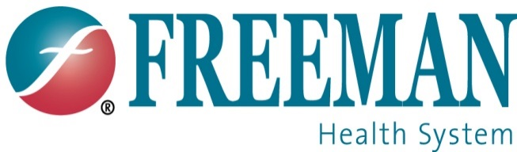

News Release

For immediate release: Wednesday, October 8, 2025

Freeman Health System Concludes Feasibility Study for Southeast Kansas Hospital

JOPLIN, Mo. – Freeman Health System has concluded a comprehensive feasibility study regarding the potential development of a hospital in Southeast Kansas. After two years of due diligence, the study revealed significant challenges that prevent them from moving forward responsibly.

Freeman was initially approached by community leaders in Southeast Kansas due to a gap in quality healthcare services. Since that time, other organizations, including Freman Health System, have stepped in and successfully filled that gap, significantly changing the healthcare landscape in the region.

“Due diligence is not a snapshot in time, it’s a continuous process,” said Matt Fry, Chief Executive Officer of Freeman Health System. “The conditions that existed two years ago no longer reflect the current reality.”

The feasibility study considered multiple factors, including the unpredictable impact of pending legislation such as the “One Big Beautiful Bill” and evolving challenges in rural healthcare. These variables, unknown at the start of the process, contributed to the final decision.

Freeman Health System remains committed to Southeast Kansas through existing services and strategic growth, including the ongoing Oncology Expansion at Freeman’s Pittsburg location.

###

About Freeman Health System
Locally owned, not-for-profit and nationally recognized, Freeman Health System includes Freeman Hospital West, Freeman Hospital East, Freeman Neosho Hospital and Ozark Center – the area’s largest provider of behavioral health services – as well as two urgent care clinics, dozens of physician clinics and a variety of specialty services. With more than 320 physicians on staff representing more than 90 specialties, Freeman provides cancer care, heart care, neurology and neurosurgery, orthopedics, children’s services, women’s services, and many others for all of the Four State Area. Freeman is also involved in numerous community-based activities and sponsored events and celebrations. Additionally, in the Joplin/Pittsburg areas, Freeman is the only Children’s Miracle Network Hospital in a 70-mile radius. For more information, visit freemanhealth.com.

